|  |  |
| --- | --- |
| 21SP041 | Planning Proposal for rezoning of land at Glendale - 35, 35A and 35B Frederick Street and 1 Glendon Crescent |

|  |  |
| --- | --- |
| Key focus area | 1. Unique landscape |
| Objective | 1.3 New development and growth complements our unique character and sense of place |
| File | RZ/3/2020 - D10033884 |
| Author | Senior Strategic Planner - Joanne Dunkerley |
| Responsible manager | Manager Integrated Planning - Wes Hain |

Executive Summary

This report presents a planning proposal for land north of Glendale owned by Eden Estates. The site is within both the Newcastle and the Lake Macquarie local government areas (LGAs), as shown in Figure 1, which adds complexities to the planning proposal process.

The purpose of this report is to request Council’s support to request a Gateway Determination from the Department of Planning, Industry and Environment (DPIE) for the planning proposal in Attachment 1, which applies to the portion of the site within the Lake Macquarie LGA.

|  |
| --- |
| Recommendation  Council:   1. requests a Gateway Determination from the Department of Planning, Industry and Environment for the planning proposal contained in Attachment 1, 2. undertakes consultation with state government agencies in accordance with the Gateway Determination, 3. receives a further report on the planning proposal before public exhibition is undertaken. |

Discussion

The Eden Estates site straddles the Newcastle and Lake Macquarie LGAs north of Glendale, with the Newcastle Link Road dividing the site. The total site area is approximately 592ha, with approximately 169ha of the site within the Lake Macquarie LGA.

The proposal seeks to rezone the site to provide more housing and employment land and to provide new community infrastructure such as open space and recreation areas along with transport networks. The proposal also seeks to protect watercourses and important ecological areas. The portion of the site in the Lake Macquarie LGA is currently zoned part RU6 Transition and part E2 Environmental Conservation under the *Lake Macquarie Local Environmental Plan 2014*. The RU6 Transition zone identifies land that may be suitable for future urban purposes subject to environmental investigations.

Site context

The majority of the site forms part of the former New Wallsend No 2 Colliery. After the mine closure the land was sold to Eden Estates. During the past 15-20 years while the mine closure process has been occurring, the area has evolved, with existing or proposed urban development now extending to the majority of the site’s perimeter.

The site is within a regionally significant catchment and growth area, with clear direction for future urban development acknowledged in the Hunter Regional Plan 2036, the Greater Newcastle Metropolitan Plan 2036, and the Lake Macquarie Local Strategic Planning Statement.

The site is well connected to catalyst areas, strategic centres, and inter-regional road networks. It forms part of and joins with regional cycling routes, and provides an opportunity to enhance multi modal transport options.

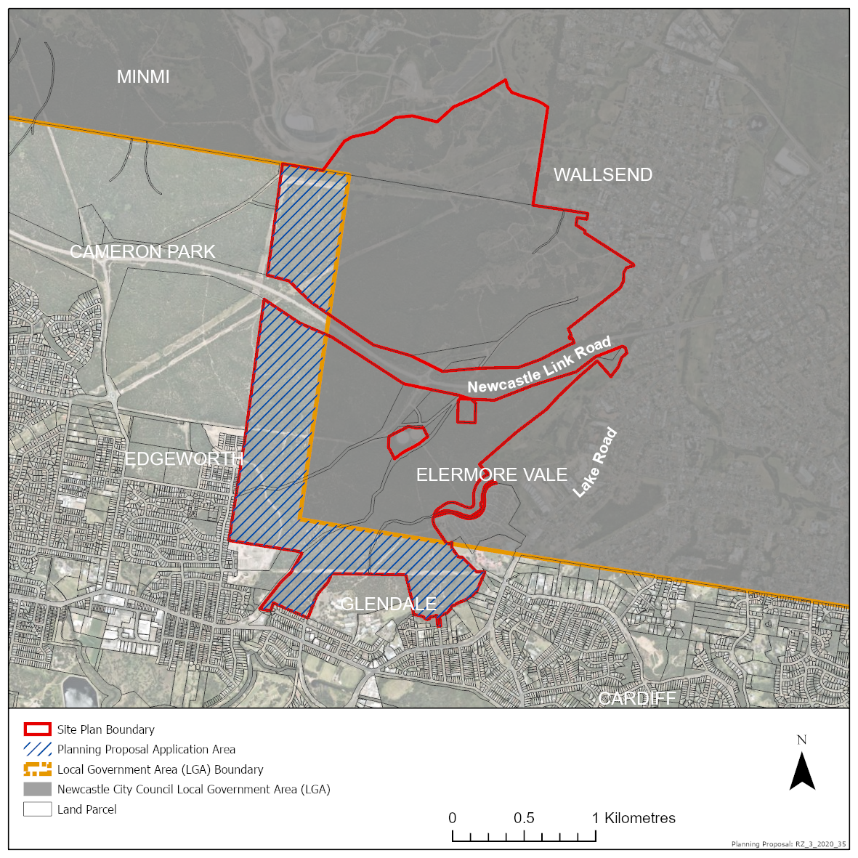

Figure 1 - Site locality plan

Preliminary Structure Plan

While this planning proposal relates to the parts of the site in the Lake Macquarie LGA, staff are working closely with the City of Newcastle and Eden Estates to ensure a holistic approach to the planning, assessment and future development of the site to achieve the best outcomes for the community. This coordinated approach, along with preliminary studies undertaken so far, has resulted in the development of a preliminary Structure Plan (Attachment 2). The Structure Plan identifies the potential allocation of urban and environmental areas, along with the distribution of community and recreation facilities. Given the size and complexity of the site, this Structure Plan will guide further detailed studies which will substantiate the capability and suitability of the land and inform zone boundaries, development standards and guidelines. The preliminary Structure Plan was developed from preliminary studies and a constraints and opportunities assessment including:

* site context
* topography and slope
* creeks and riparian corridors
* high points and ridgelines
* biodiversity and habitat
* Aboriginal cultural heritage
* access
* geotechnical stability
* infrastructure and easements.

Design principles for the site have been identified, which were used to guide the development of the preliminary Structure Plan and will also be used to prepare an Area Plan containing site-specific development guidelines. Broadly, the design principles are:

* Activity – promote a mix of interesting and attractive uses, places and buildings
* Connectivity – enable strong physical and social connections and movement
* Community – foster engaged, inclusive communities to participate and connect
* History – recognise and understand previous occupants and their legacy
* Placemaking – create a strong vibrant identity
* Housing – provide diversity and various densities of housing
* Biodiversity – protect important natural areas and integrate future development with these natural areas
* Sustainability – provide resilient and efficient neighbourhoods.

While staff from the City of Newcastle and Lake Macquarie City are working together, each council is pursuing separate planning proposals and requesting Gateway Determination individually and prior to further studies being undertaken. Seeking Council’s support to request a Gateway Determination now will:

* recognise the strategic and site-specific merit of the proposal
* demonstrate the intent of both councils
* provide Eden Estates with the confidence to continue with site investigations and the rezoning process in a timely manner
* enable the continued coordination of the studies across LGA boundaries to provide the best planning and development outcome for the whole site.

Prior to exhibition, all studies will need to be completed and the proposed zone boundaries clarified. The proposed land use zones will be reported to each council for consideration before the planning proposal is placed on public exhibition. It is anticipated that studies will be completed around the end of 2021.

Assessment of options

Seeking a Gateway Determination will clarify the position of Council and enable a coordinated approach to the planning and future development of the site. It will avoid disjointed land use decisions, or the development of the site on one side of the LGA boundary out of sync with the other, producing better environmental, social and economic outcomes for the site.

The Gateway Determination process will advise what further specific studies and consultation is required. This ensures urban and environmental conservation zones along with other development standards can be refined in a coordinated way, following Gateway Determination.

Council could decide not to support the recommendation. This is not preferred as the proposal has strategic and site-specific merit established in regional and local strategic planning documents. If a Gateway Determination is pursued at a later date, opportunities for a coordinated approach could be lost.

Community engagement and internal consultation

Internal consultation occurred through Council's Rezoning Advisory Panel, which includes Council staff from Integrated Planning, Asset Management, Environmental Systems, Development Assessment and Certification and Property and Business Development.

Community consultation and public exhibition will occur following the Gateway Determination and after a future report on the planning proposal is considered by Council. Consultation with relevant government agencies will occur as directed by the Gateway Determination.

Key considerations

|  |  |
| --- | --- |
| **Economic impacts** | The planning proposal will have positive economic impacts by providing land for housing in close proximity to jobs and services in strategic economic centres and catalyst areas, supporting the viability of those centres.  High level estimates of development yield indicate between 3000 and 4000 homes will be provided within the site, with approximately 750 to 1000 homes within the Lake Macquarie LGA. The eventual yield is subject to the outcomes of further site investigations.  A detailed economic impact assessment will be undertaken. Based on the high-level estimates of yield, a preliminary economic impact of the future development within the part of the site in the Lake Macquarie LGA suggests it will provide homes for approximately 2000 people and generate roughly $242 million in economic output. Construction works (subdivision and buildings) are estimated to support around 540 direct jobs and 1100 indirect jobs, increasing economic output in the City by around $752 million. |
| **Environment** | Parts of the site have significant biodiversity values. Ecological assessment and survey work commenced in January 2020, in accordance with the state government’s biodiversity assessment and certification process, to identify biodiversity values and local habitat linkages to support the natural landscape. The outcomes of the ecological assessment will inform the final urban and environmental zone boundaries, and support environmental sustainability principles. The ecological assessment will be presented in a Biodiversity Certification Assessment Report, which is intended to be exhibited with the planning proposal.  Based on the preliminary Structure Plan contained in Attachment 2, roughly 200ha of the site is proposed to be conserved for environmental outcomes. This figure may change based on the outcomes of the studies which are being undertaken.  Other studies such as contamination, geotechnical, bushfire, flooding and cultural heritage have commenced and will be finalised following Gateway Determination. These studies will identify any issues that need to be considered in determining the final urban and environmental zone boundaries for the site. |
| **Community** | A social infrastructure assessment and social impact analysis has commenced and will be finalised over the coming months. This will be used to refine the Structure Plan and determine appropriate zones, development standards and development guidelines. Social sustainability will be achieved through the identification and provision of community facilities, open space, sports and recreation facilities, transport networks, schools and housing diversity. |
| **Civic leadership** | The recommendation supports sustainable governance through the collaborative approach taken with City of Newcastle to achieve the best results for the site and the current and future community. |
| **Financial** | There are minimal financial implications to Council associated with the recommendation. The costs associated with this planning proposal, including staff time, are being covered by the landowner as per Council’s rezoning fees, listed in Council’s fees and charges.  Local infrastructure contributions will be paid as part of any future development of the site. There will be costs associated with the maintenance of future public infrastructure, including roads, and recreation and community facilities, although this will be offset by the rates that will be collected from future development. |
| **Infrastructure** | The site is located on the arterial road network with access to the Newcastle Link Road and other road connections in the surrounding urban area. A traffic and transport assessment has commenced and will determine requirements for new or upgraded intersections, along with appropriate transport networks within the site. The site has access to all other infrastructure including water, sewer, electricity, gas and telecommunications, which will be extended to service the future development of the site. |
| **Risk and insurance** | The preparation of a planning proposal is a standard activity and any risks associated with this are minimised by following the process outlined in the *Environmental Planning and Assessment Act 1979,* the *Environmental Planning and Assessment Regulation 2000,* and Council’s Local Environmental Plan Amendment Procedure.  Given the complexity of the site, this planning proposal presents certain specific risks. If Council was not to support the recommendation, the proponent may request a review of Council’s decision by the Regional Planning Panel. This presents a reputational risk for Council and may impact the timely progression of the proposal and the working relationship with Eden Estates and the City of Newcastle. |

Legislative and policy considerations

The recommendations of this report are consistent with:

*Environmental Planning and Assessment Act 1979*

*Environmental Planning and Assessment Regulation 2000*

Hunter Regional Plan 2036

Greater Newcastle Metropolitan Plan 2036

Lake Macquarie Local Strategic Planning Statement

Lake Macquarie Housing Strategy

*Lake Macquarie Local Environmental Plan 2014*

Attachments

|  |  |  |  |
| --- | --- | --- | --- |
| 1. | Planning Proposal | Under separate cover | D10095065 |
| 2. | Preliminary Structure Plan | Under separate cover | D09971737 |